1. **Write a program to replace a substring inside a string with other string ?**

import java.util.Scanner;

public class Exercise1 {

    public static void main(String args[])

    {

        System.out.println("Enter the String: ");

        Scanner scanner = new Scanner(System.in);

        String input = scanner.nextLine();

        String s = new String (input);

System.out.println("Enter the Sub-String to be replaced: ");

        String substring = scanner.nextLine();

System.out.println("Enter the Sub-String to be replaced with: ");

        String newstring = scanner.nextLine();

String replace = s.replace(substring, newstring);

        System.out.println("New String is: ");

System.out.println(replace);

    }

}

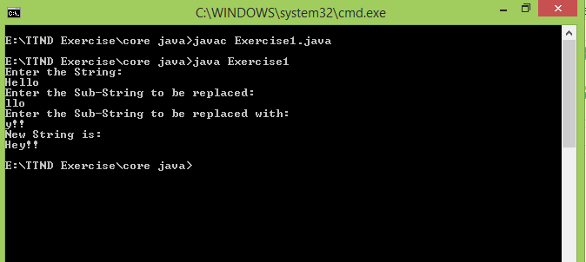

1. **Write a program to find the number of occurrences of the duplicate words in a string and print them ?**

**import** java.util.Scanner;  
  
**public class** Exercise2 {  
 Scanner **sc**=**new** Scanner(System.***in***);  
 **void** getDuplicateWords(){  
 String str;  
 System.***out***.println(**"Enter a String"**);  
 str=**sc**.nextLine();  
 **int** count = 0;  
 String[] str1= str.split(**"\\s"**);  
 System.***out***.println(**"Duplicate words are:-"**);  
 **for**(**int** i=0;i<str1.**length**;i++) {  
 **if** (str1[i] != **null**) {  
 count = 1;  
 **for** (**int** j = i + 1; j < str1.**length**; j++) {  
  
 **if** (str1[i].equals(str1[j])) {  
 str1[j] = **null**;  
 count++;  
  
 }  
  
 }  
 **if**(count > 1)  
 System.***out***.println(str1[i] + **" occured "** + count + **" times "**);  
 }  
 }  
 }  
  
 **public static void** main(String[] args){  
 Exercise2 obj=**new** Exercise2();  
 obj.getDuplicateWords();  
  
 }  
}

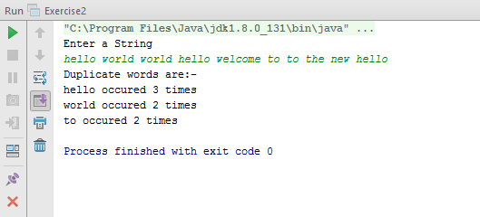

1. **Write a program to find the number of occurrences of a character in a string without using loop?**

**import** java.util.Scanner;  
**public class** Exercise3 {  
  
 **public static void** main(String args[])  
 {  
 Scanner sc= **new** Scanner(System.***in***);  
 System.***out***.println(**"Enter String :"**);  
 String input = sc.nextLine();  
 System.***out***.println(**"Enter The Character To Find : "**);  
 String ch = sc.nextLine();  
  
  
 **int** count= input.length() - input.replaceAll(ch,**""**).length() ;  
 System.***out***.println(**"count = "** + count);  
  
 }  
  
 }

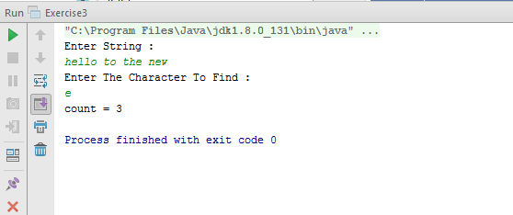

1. **Calculate the number & Percentage Of Lowercase Letters,Uppercase Letters, Digits And Other Special Characters In A String**

import java.util.Scanner;

class Exercise4

{

public static void main(String args[])

{

System.out.println("Enter the String");

Scanner scanner = new Scanner(System.in);

String input = scanner.nextLine();

int strlength = input.length();

int lowerChar = 0, upperChar = 0, digit = 0,specialChar = 0;

for(int i = 0; i < strlength; i++)

{

if(Character.isLowerCase(input.charAt(i)))

lowerChar++;

else if(Character.isUpperCase(input.charAt(i)))

upperChar++;

else if(Character.isDigit(input.charAt(i)))

digit++;

else

specialChar++;

}

System.out.println("Number of Lower Characters: "+lowerChar);

System.out.println("Percentage of Lower Characters: "+lowerChar*100.0/strlength+"%");

System.out.println("Number of Upper Characters: "+upperChar);

System.out.println("Percentage of Upper Characters: "+upperChar*100.0/strlength+"%");

System.out.println("Number of Digits: "+digit);

System.out.println("Percentage of Digits: "+digit*100.0/strlength+"%");

System.out.println("Number of Special Characters: "+specialChar);

System.out.println("Percentage of Special Characters: "+specialChar*100.0/strlength+"%");

}

}

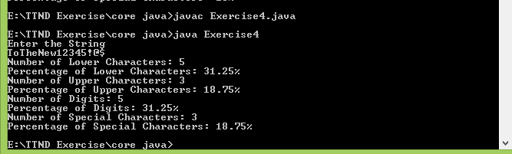

1. **Find common elements between two arrays.**

import java.util.Scanner;

public class Exercise5 {

public static void main(String args[]){

System.out.print("Enter the no. of elements in Array1: ");

Scanner scanner = new Scanner(System.in);

int arr1_length = scanner.nextInt();

int arr1[] = new int[arr1_length];

System.out.println("Enter the elements in Array1: ");

for(int i= 0; i < arr1_length; i++)

{

arr1[i] = scanner.nextInt();

}

System.out.print("Enter the no. of elements in Array2: ");

int arr2_length = scanner.nextInt();

int arr2[] = new int[arr2_length];

System.out.println("Enter the elements in Array2: ");

for(int i= 0; i < arr2_length; i++)

{

arr2[i] = scanner.nextInt();

}

System.out.println("Common elements are: ");

for(int i=0;i<arr1.length;i++){

for(int j=0;j<arr2.length;j++){

if(arr1[i]==arr2[j]){

System.out.println(arr1[i]);

}

}

}

}

}

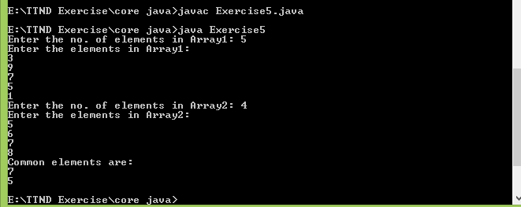

1. **There is an array with every element repeated twice except one. Find that element?**

import java.util.Scanner;

public class Exercise6 {

public static void main(String args[]){

System.out.print("Enter the no. of elements in Array1: ");

Scanner scanner = new Scanner(System.in);

int arr1_length = scanner.nextInt();

int arr1[] = new int[arr1_length];

int result = 0;

System.out.println("Enter the elements in Array1: ");

for(int i= 0; i < arr1_length; i++)

{

arr1[i] = scanner.nextInt();

result ^= arr1[i];

}

System.out.println("Single element is: "+result);

}

}

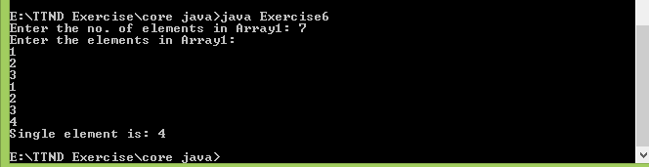

1. **Write a program to print your Firstname,LastName & age using static block,static method & static variable respectively**

class Exercise7

{

static String firstName ;

static String lastName ="Code Studio";

static{

firstName = "Visual";

}

static void last(){

System.out.println("Last Name: "+lastName);

}

static int age = 7;

public static void main(String args[]){

System.out.println("First Name: "+firstName);

last();

System.out.println("Age: "+Exercise7.age);

}

}

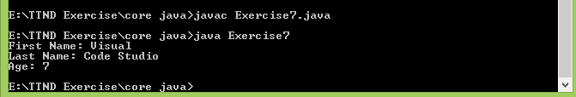

1. **Write a program to reverse a string and remove character from index 4 to index 9 from the reversed string using String Buffer.**

**import** java.util.*;  
**public class** Exercise8 {  
 **public static void** main(String[] args) {  
  
 System.***out***.println(**"Enter a string: "**);  
 Scanner sc = **new** Scanner(System.***in***);  
 String str = sc.nextLine();  
*// Reverse using StringBuilder* StringBuilder stringBuilder = **new** StringBuilder();  
 **char** []ch = str.toCharArray();  
 **for** (**int** i = str.length()-1; i>= 0;i-- ){  
 stringBuilder.append(ch[i]);  
 }  
  
 stringBuilder.replace(4,10,**""**);  
 System.***out***.println(**"Using String Builder Reversed String is: "**+stringBuilder);  
  
 *// Reverse using StringBuffer* String strReverse = **new** StringBuffer(str).reverse().replace(4,10,**""**).toString();  
 System.***out***.println(**"Using String Buffer Reverse String is: "**+strReverse);  
  
 }  
}

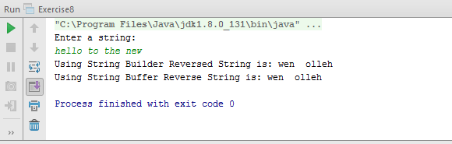

1. **Write a program to read text file & print the content of file using String Builder.**

**import** java.io.*;  
**public class** Exercise9 {  
  
 **public static void** main(String[] args) {  
 **try** {  
  
 BufferedReader br = **new** BufferedReader(**new** FileReader(**"E:\\TTND Exercise\\exercise\\src\\input.txt"**));  
  
 StringBuilder sb = **new** StringBuilder();  
 String line = br.readLine();  
 **while** (line != **null**) {  
 sb.append(line);  
 sb.append(**"\n"**);  
 line = br.readLine();  
 }  
  
 System.***out***.println(sb);  
 }  
 **catch**(IOException e){  
 e.printStackTrace();  
 }  
  
 }  
  
  
}

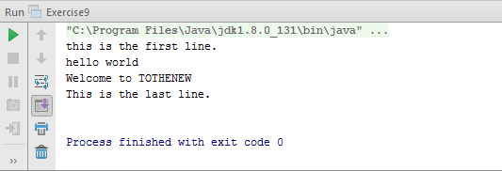

1. **Write a program to display values of enums using a constructor & getPrice() method(Example display house & thier prices ).**

**enum** House {  
 ***Villa***(1000),***Hut***(200),***Apartment***(500);  
 **private int** price;  
 House(**int** p) {  
 price = p;  
 }  
 **int** getPrice() {  
 **return** price;  
 }  
 **public static void** main(String args[]){  
 System.***out***.println(**"All house prices:"**);  
 **for** (House h : House.*values*()) System.***out***.println(  
 h + **" costs "** + h.getPrice() + **"$"**);  
 }  
}

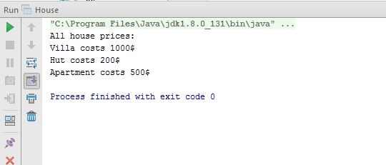

1. **Write a single program for following operation using overloading A) Adding 2 integer number B) Adding 2 double C) Multipling 2 float d) Multipling 2 int E) concate 2 string F) Concate 3 String**

class Exercise11

{

public

int add(int a,int b)

{

return a+b;

}

double add(double a, double b)

{

return a+b;

}

float multiples(float a, float b)

{

return a*b;

}

int multipl(int a, int b)

{

return a*b;

}

String concate(String a, String b)

{

return a+b;

}

String concate(String a, String b, String c)

{

return a+b+c;

}

}

public class Exercise11main{

public static void main(String args[]) {

Exercise11 obj = new Exercise11();

System.out.println("Calling add(int a, int b);");

System.out.println("Result: "+obj.add(6,8));

System.out.println("Calling double add(double a, double b);");

System.out.println("Result: "+obj.add(6.5568787, 8.275768));

System.out.println("Calling multiplty(float a,float b);");

System.out.println("Result: "+obj.multiples( (float) 0.4, (float) 2.1));

System.out.println("Calling multiply(int a, int b);");

System.out.println("Result: "+obj.multipl(2,5));

System.out.println("Calling concate(String a, String b);");

System.out.println("Result: "+obj.concate("hello ", "world"));

System.out.println("Calling concate(String a, String b, String c);");

System.out.println("Result: "+obj.concate("this", " is", " example"));

}

}

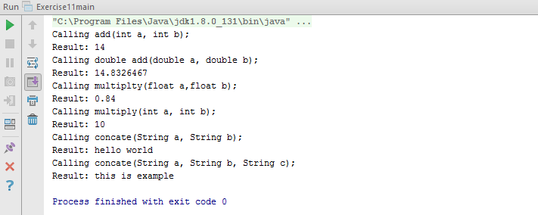

1. **Create 3 sub class of bank SBI,BOI,ICICI all 4 should have method called getDetails which provide there specific details like rateofinterest etc,print details of every banks.**

**class** Bank {  
  
 **void** getDetails() {  
 System.***out***.println(**"Super Class Bank Details:"**);  
  
 }  
}  
  
**class** SBI **extends** Bank{  
 **void** getDetails() {  
 System.***out***.println(**"Bank Details:"**);  
 System.***out***.println(**"State Bank of India"**);  
 System.***out***.println(**"Rate of Interest: 10%"**);  
 }  
  
}  
  
**class** BOI **extends** Bank {  
 **void** getDetails() {  
 System.***out***.println(**"Bank Details:"**);  
 System.***out***.println(**"Bank of India"**);  
 System.***out***.println(**"Rate of Interest: 8%"**);  
 }  
  
}  
  
**class** ICICI **extends** Bank {  
 **void** getDetails() {  
 System.***out***.println(**"Bank Details:"**);  
 System.***out***.println(**"ICICI"**);  
 System.***out***.println(**"Rate of Interest: 12%"**);  
 }  
  
}  
  
**class** Exercise12 {  
 **public static void** main(String args[]) {  
 Bank obj = **new** SBI();  
 obj.getDetails();  
  
 obj = **new** BOI();  
 obj.getDetails();  
  
 obj = **new** ICICI();  
 obj.getDetails();  
  
  
 }  
}

